TRIANGLE Project

Form:

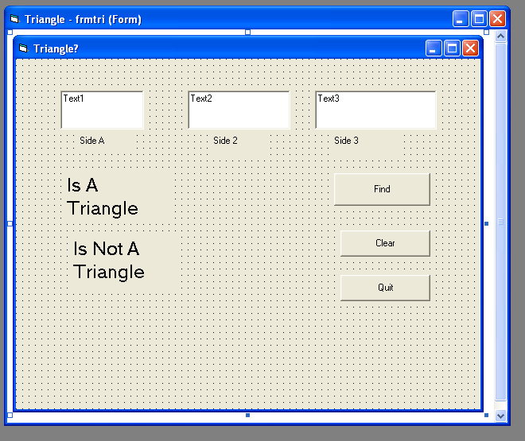

Code:

Private Sub cmdfind_Click()

Dim a As Integer, b As Integer, c As Integer

a = Val(txta)

b = Val(txtb)

c = Val(txtc)

If a + b > c And a + b > c And a + b > c Then

lblis.Visible = True

' This is where the rest of the tests for what kind of triangle will go'

Else

lblisnot.Visible = True

End If

End Sub

Grading Rubric:

“B” *Test for triangle

*Test for kind of triangle

- equilateral

- isosceles

- scalene

- right

________________________________________________________________

“A” - obtuse

- acute

*Area and Perimeter

*Angles

*Pictures and/or diagrams